Experiment: 3
MATLAB Analysis of Spectrum Bands, Propagation Loss and Cellular Interference
OBJECTIVES:
By the end of the experiment, students should be able to:
1. Calculate or simulate path loss at representative sub-1 GHz, mid-band and mmWave frequencies. 2. Compare estimated received signal strength as frequency and distance change.
3. Examine how cell separation or frequency reuse changes a simplified interference ratio
. 4. Relate the results to coverage and spectrum-use considerations across mobile generations, while stating model limitations.
PROGRAME CODE:
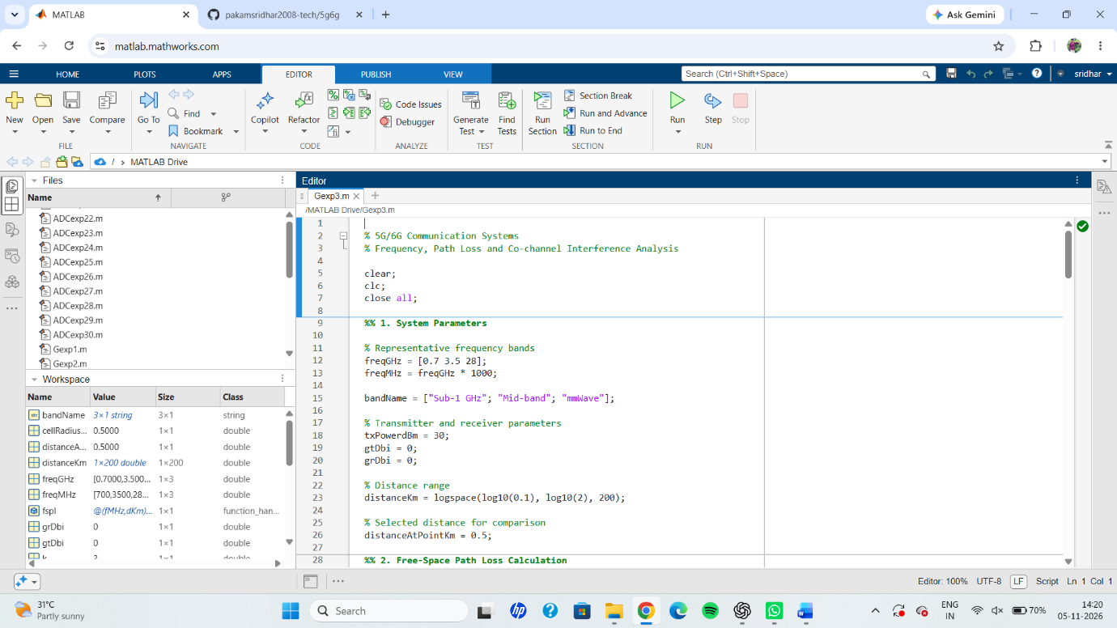
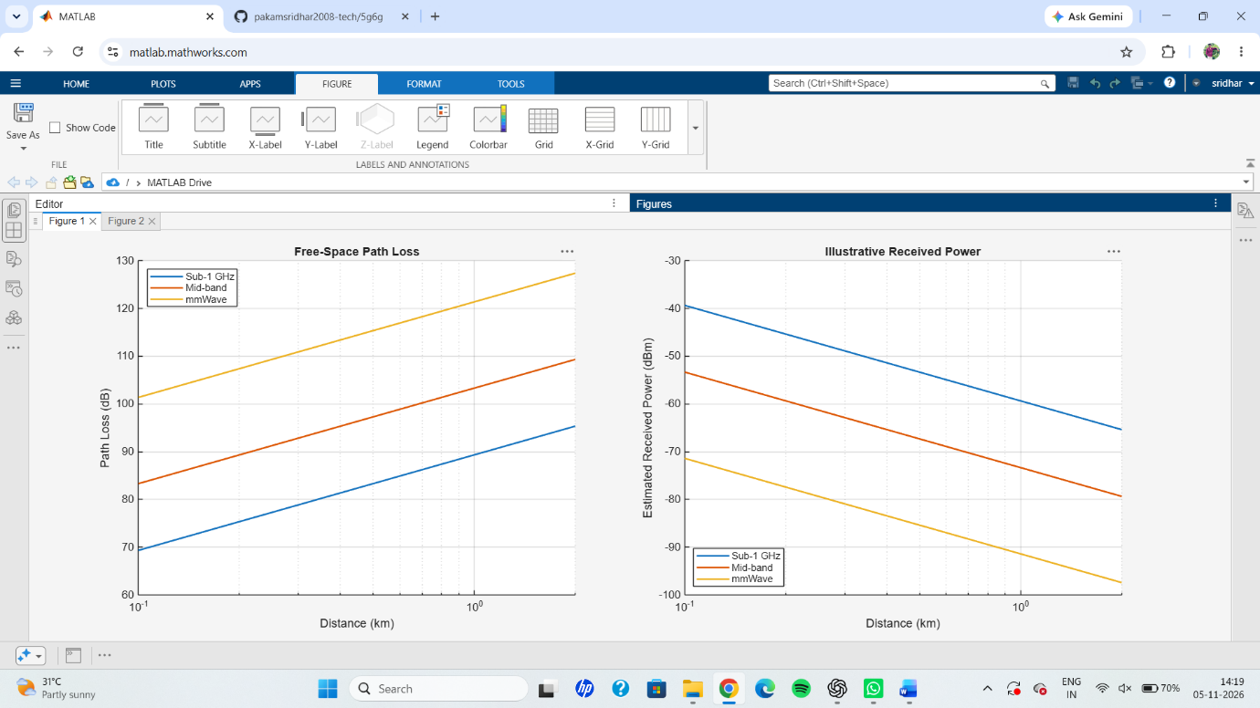
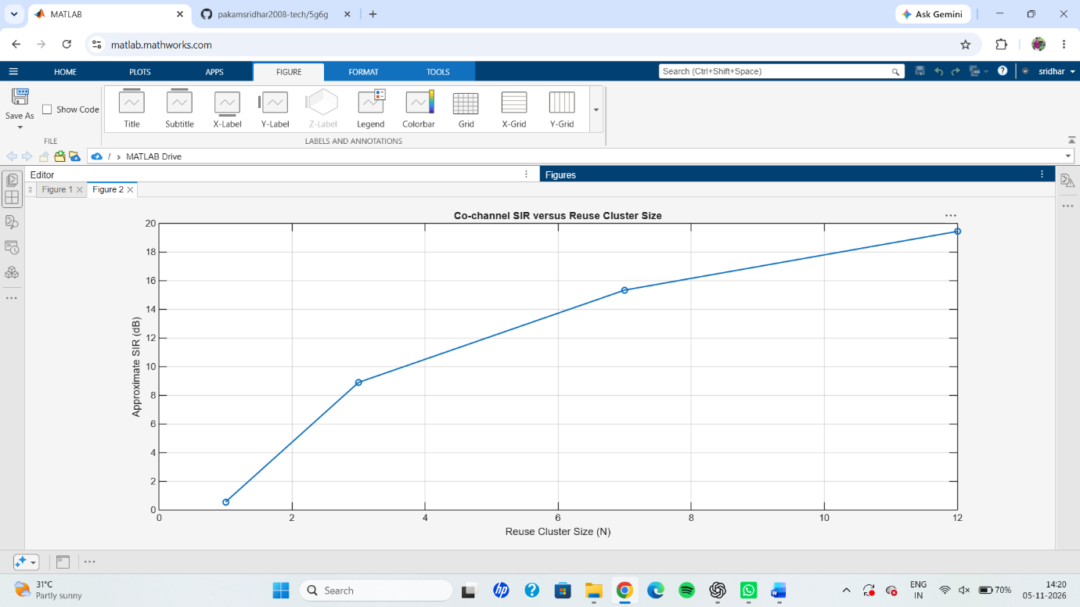
RESULT: The frequency band comparison, free-space path loss and co-channel interference analysis were successfully simulated using MATLAB. The results showed that path loss increases with frequency and distance. At a distance of 0.5 km, the estimated received powers were −53.32 dBm at 0.7 GHz, −67.30 dBm at 3.5 GHz and −85.36 dBm at 28 GHz. The frequency reuse analysis demonstrated that SIR improves as the reuse cluster size increases. The three graphs clearly illustrated the relationship between frequency, distance, received power and co-channel interference. Thus, the experiment demonstrated important link-budget and frequency-reuse concepts used in 5G/6G communication systems.

